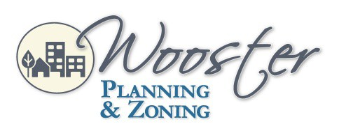
City Hall
1st Floor Council Chambers 538 North Market Street Wooster, OH 44691
City of Wooster Planning Commission
Meeting Agenda
September 1, 2022 6:30 pm
- Roll Call

- Approval of the July 7, 2022, Meeting Minutes

- Applications
PC-22-7 Josh Funderburk requesting Conditional Use for automotive fuel sales at 310 South Market Street with parcel numbers 64-01740.000, 64-01226.000, 64-01739.000,64-01741.000, and 64-00149.000 in a C-4 (Central Business District) zoning district.
The applicant has withdrawn this application.

PC-22-19 John Long requesting approval for a Preliminary Development Plan for the construction of 30 apartments on Noble Drive with permanent parcel number 67-02982.006 in a C-3 (General Commercial) zoning district.

PC-22-20 John Long requesting approval for a Conditional Use permit for the construction of 30 apartments on Noble Drive with permanent parcel number 67-02982.006 in a C-3 (General Commercial) zoning district.
This Application Will Include a Public Hearing

PC-22-21 Christine Sampat requests approval for a Preliminary Development Plan for constructing two medical offices on Enterprise Parkway with permanent parcel number 67-02030.006 in a C-3 (General Commercial) zoning district.

- Adjournment

Please contact the Planning & Zoning Division at 330-263-5238 for questions or comments regarding this Agenda.

