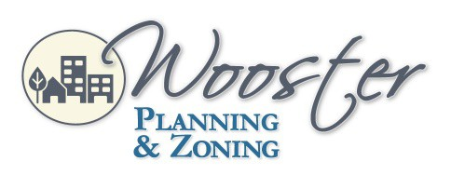
City Hall
1st Floor Council Chambers 538 North Market Street Wooster, OH 44691
City of Wooster Design and Review Board
Meeting Agenda
September 1, 2022 5:30 pm
- Roll Call

- Approval of the August 4, 2022, Meeting Minutes

- Applications
DR-22-9 Josh Funderburk requesting an approval recommendation for a mixed use consisting of automotive fuel sales, restaurant, and retail building at the property located at the northeast corner of South Market Street and East Henry Street with parcel numbers 64-01740.000, 64-01226.000, 64-01739.000, 64-01741.000 and 64-00149.00 in the C-4 (Central Business) zoning district.
The applicant has withdrawn this application.

DR-22-29 Paul Magee of LetterGraphics requesting approval of wall, hanging, and window signs at 217 East Liberty Street in a C-4 (Central Business) zoning district (non-landmark).

- Adjournment

Please contact the Planning & Zoning Division at 330-263-5238 for questions or comments regarding this Agenda.

City of Wooster Design and Review Board
Meeting Agenda
July 1, 2021 5:30 p.m.

