City Hall
1st Floor Council Chambers 538 North Market Street Wooster, OH 44691
City of Wooster Board of Building and Zoning Appeals
Meeting Agenda
September 1, 2022 7:30 pm
- Roll Call

- Approval of the August 4, 2022, Meeting Minutes

- Applications
BZA-22-5 Josh Funderburk requesting an Area variance from Planning and Zoning Code Section 1115.04 (a) regarding the maximum front yard setback, Section 1125.03(b)(5) regarding parking located behind the front building line, and Section 1125.03(b)(5) regarding parking setback from abutting lot lines at 310 South Market Street (Parcel numbers 64-01740.000, 64-01226.000, 64-01739.000, 64-01741.000 and 64-00149.000).
The applicant has withdrawn this application.

BZA-22-18 Benjamin Juneo requesting an Area Variance from Planning and Zoning Code Section 1113.01(d)(3) to allow an accessory building in the front yard at 2796 Cleveland Road in a C-3 (General Commercial) zoning district.
This Application Will Include a Public Hearing

BZA-22-19 Karen Dodge requesting an area variance from Planning and Zoning Code Section 1127.10(d)(2) to allow a freestanding sign that exceeds the permitted size and height at 4536 Cleveland Road in a C-3 (General Commercial) zoning district.
This Application Will Include a Public Hearing

- Adjournment

Please contact the Planning & Zoning Division at 330-263-5238 for questions or comments regarding this Agenda.

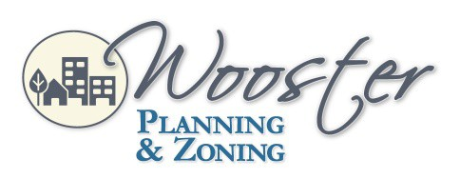
City of Wooster Design and Review Board
Meeting Agenda
July 1, 2021 5:30 p.m.

