City Hall
1st Floor Council Chambers 538 North Market Street Wooster, OH 44691
City of Wooster Planning Commission
Meeting Agenda
June 2, 2022 6:30 pm
- Roll Call

- Approval of the May 5, 2022, Meeting Minutes

- Applications
PC-22-7 Josh Funderburk requesting Conditional Use for automotive fuel sales at 310 South Market Street with parcel numbers 64-01740.000, 64-01226.000, 64-01739.000,64-01741.000, and 64-00149.000 in a C-4 (Central Business District) zoning district.
The applicant has tabled this application.

PC-22-12 J. Douglas Drushal requesting Final Development Plan approval for the construction of 12 tennis courts at 801 E. Wayne Avenue with permanent parcel number 65-02031.000 in a CF (Community Facilities) zoning district.

- Adjournment

Please contact the Planning & Zoning Division at 330-263-5238 for questions or comments regarding this Agenda.
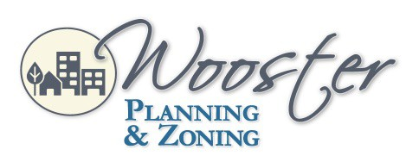
City of Wooster Design and Review Board
Meeting Agenda
July 1, 2021 5:30 p.m.

