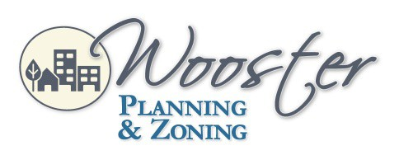
City Hall
1st Floor Council Chambers 538 North Market Street Wooster, OH 44691
City of Wooster Design and Review Board
Meeting Agenda
June 2, 2022 5:30 pm
- Roll Call

- Approval of the May 5, 2022, Meeting Minutes

- Applications
DR-22-9 Josh Funderburk requesting an approval recommendation for a mixed use consisting of automotive fuel sales, restaurant, and retail building at the property located at the northeast corner of South Market Street and East Henry Street with parcel numbers 64-01740.000, 64-01226.000, 64-01739.000, 64-01741.000 and 64-00149.00 in the C-4 (Central Business) zoning district.
The applicant has tabled this application.

DR-22-18 Julie McNabb requesting a Certificate of Appropriateness for exterior painting and awning at 114 East Liberty in the C-4 landmark (Central Business) zoning district.

DR-22-20 Jim Renfrow requesting a development plan recommendation to alter the exterior by installing new awnings, windows, door, painting, and signs at 135 North Bever Street, located within the C-4 non-landmark (Central Business) zoning district.

DR-22-21 Erin Stiffler of Sign Design Wooster requesting a Certificate of Appropriateness for second-floor window signs at 121 North Market Street in a C-4 landmark (Central Business) zoning district.

- Adjournment

Please contact the Planning & Zoning Division at 330-263-5238 for questions or comments regarding this Agenda.

City of Wooster Design and Review Board
Meeting Agenda
July 1, 2021 5:30 p.m.

