City Hall
1st Floor Council Chambers 538 North Market Street Wooster, OH 44691
City of Wooster Board of Building and Zoning Appeals
Meeting Agenda
June 2, 2022 7:30 pm
- Roll Call

- Approval of the May 5, 2022, Meeting Minutes

- Applications
BZA-22-5 Josh Funderburk requesting an Area variance from Planning and Zoning Code Section 1115.04 (a) regarding the maximum front yard setback, Section 1125.03(b)(5) regarding parking located behind the front building line, and Section 1125.03(b)(5) regarding parking setback from abutting lot lines at 310 South Market Street (Parcel numbers 64-01740.000, 64-01226.000, 64-01739.000, 64-01741.000 and 64-00149.000).
The applicant has tabled this application.

BZA-22-8 James Worthington requesting an Area Variance from Planning and Zoning Code Sections 1109.03(6)D and 1125.03(h)(3) to allow a parking area for car sales and driveway area without a hard surface at 3669 Cleveland Road in a C-3 (General Commercial) zoning district.
This Application Will Include a Public Hearing

BZA-22-9 Matthew Knight requesting an Area Variance from Planning and Zoning Code Section 1113.01(e)8D to allow a fence using rolled wire/chicken wire at 4029 Cleveland Road in a C-3 (General Commercial) zoning district.
This Application Will Include a Public Hearing

BZA-22-10 J. Douglas Drushal requesting a Use Variance from Planning and Zoning Code Section 1109.02(d) to allow an expansion of a vehicle washing establishment at 611 West Liberty Street in a C-2 (Community Commercial) zoning district.
This Application Will Include a Public Hearing

- Adjournment

Please contact the Planning & Zoning Division at 330-263-5238 for questions or comments regarding this Agenda.
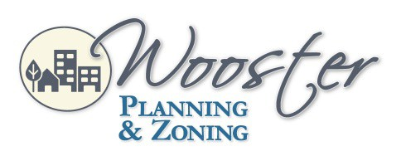
City of Wooster Design and Review Board
Meeting Agenda
July 1, 2021 5:30 p.m.

