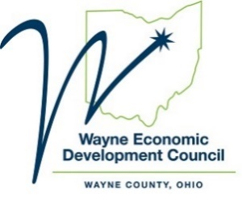
Celebrating Wayne County’s Economic Success!
March 5, 2021
The highly anticipated Micropolitan rankings have recently been released from POLICOM Corporation and Site Selection magazine. In the 2021 POLICOM Strength Ranking, Wayne County placed 14th nationally and was No. 1 in Ohio for the 4th year in a row. In addition, Site Selection Magazine released their Governor's Cup rankings in Site Selection Magazine and Wooster/Wayne County placed 7th nationally in new project expansions.

POLICOM is an independent economic research firm based in Palm City, FL, specializing in local and state economies' analytics. Formulas used to assess economic strength measure how the economy overall has performed in the previous years. Growth and size of the regional economy, changes in business sectors that typically show how much money is flowing into a community, and local trends in welfare and Medicare are all taken into account when processing this data.

The Top Micropolitan rankings are part of the Governor's Cup awards given by Site Selection Magazine. The publication annually ranks counties across the country based upon new investments and jobs announced in the previous year. This recognition is highly sought after and respected in the economic development community. As such, this is a great honor for Wayne County.

"This consistent recognition speaks volumes to the great work and collaboration within our private and public sectors. We are very proud of the efforts by our small staff at the WEDC and the dedication from the community partners", said Wayne Economic Development Council President Tom Pukys. "Wayne County is a great place to do business, and we are committed to working together to help grow existing businesses and welcome those who look to locate here."

For more information contact:
Tom Pukys, President
Wayne Economic Development Council
Office 330.264.2411 I Mobile 330.495.1882 I Email tpukys@waynecountyedc.com

